Pet Shop Management System

## Aim

## “Pets Shop Management” is the process of defining the architecture, modules, interfaces, and data for a system to satisfy specified requirements. The projects are to provide a web-based interface to a pet shop owner to manages his pet shop activities.

**Introduction**

As to use this Pet Shop Management System all its user will have a valid user id and password associated with it. Admin will responsible to provide their user id and password by creating it. Admin can grant special permission to any particular working employee. Admin can add new user, delete user, modify user, generate bill, and get information on cash inflow and outflow. Check stock, get reports on sales and purchase of products from suppliers and get information on their regular customers to provide special discounts.

Valid user or working employee will be able to enter product details, their code, and price and categorize products according to their size and price. This user can also search any particular product using price and size options as well as using product code options to check whether it is available in the pet shop management system or not.

Bill section of pet shop management system will generate bill details such as bill number which will be unique for each customer and supplier. If the bill is for customer, then it will include product type, size, number of items purchased, tax rate, total rate along with customer name and address.

It the bill is prepared for supplier then it will include supplier name, address, type of product supplied, and date of receiving, total number of items, total price, and date of payments, how much is left to be given for that particular supplier.

Admin will also able to prepare balance sheet for their business transactions for a particular date, between given period, weekly basis or monthly basis or as per user requirement.

**Objectives**

To provide web based interface to a pet shop owner to manage his pet shop activities.

To provide an option for storing and managing the basic information about pets pet products in the shop.

To provide an option for storing and managing the sales details of the shop.

To provide an option for storing and managing the basic information about customer.

To track the information about sold pets and products to a customer.

**Scope**

I am responsible to back-end part of the system. Allowing administrator do all the maintenance in the system. Allowing all users to register and use our system. And design the basis function to reduce the workload of the users such as sales module.

**Process description**

Logic System with password protection.

Storing and managing the basic information about pets and pet product in the shop.

Storing and managing the scales details of the shop.

Storing and managing the basic information about the customer.

Track the information about sold pets and products to a customer.

Add pet animal and birds details.

Add products related to the animals for sales.

Keep track of your sales.

**ER DIAGRAM OF PETSHOP MANAGEMENT SYSTEM**

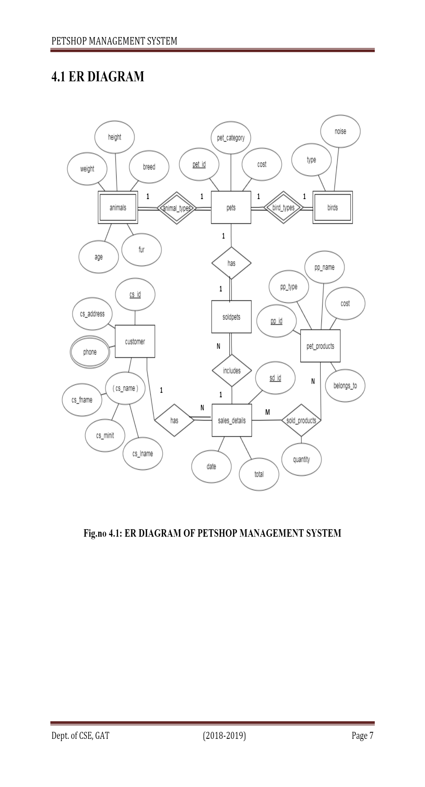

**MAPPING OF ER DIAGRAM TO SCHEMA DIAGRAM**

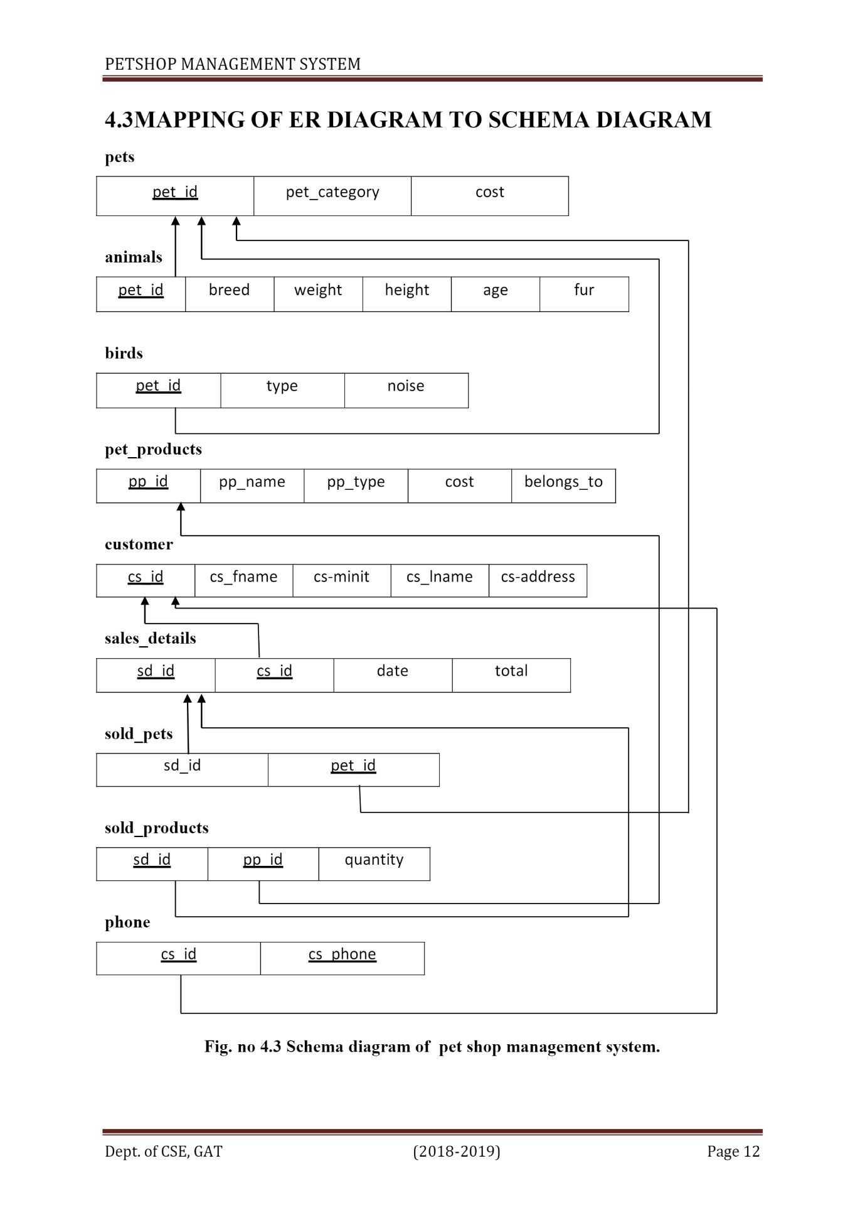

**REQUIREMENT SPECIFICATION**

**SOFTWARE REQUIREMENTS**

Operating System : 64bit operating system, x64-based process

Database : MYSQL

Tools : PHP, Xampp Server 3.2.2

**HARDWARE REQUIREMENTS**

Process : Intel R Celeron R CPU [N3060@1.60GHz](mailto:N3060@1.60GHz)

RAM : 4.00 GB

Hard Disk : 1 TB

Compact Disk : CD-ROM, CD-R, CD-RW

Input device : Keyboard, mouse

Output device : Monitor screen